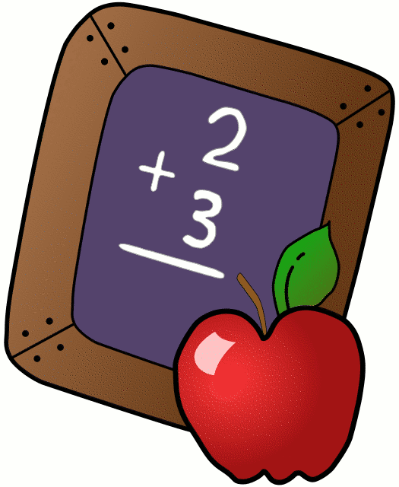
Dear Parents of Joey,
My name is Thomas Tollakson and your son is in my third grade classroom this year. I am very excited about this year as it is coming upon us quickly. I graduated from the University of Wisconsin-Platteville with a bachelor’s degree in Elementary Education with a Special Education Inclusion minor. I also have an Early Childhood minor as well. I currently live in Argyle where I am close with my family.
I am looking forward to this year with your son and his classmates. Our classroom will be filled with literature, motivational quotes, letters, numbers, and bright colors. The student’s projects will also be displayed in the classroom and hallway. Students will also have a part in creating bulletin boards to show what we learned and discussed in class.
Expectations of students and parents:
- Students are expected to be on time for school every morning if possible
- Students are expected to display appropriate behavior at all times
- Students are expected to use appropriate language
- Students are expected to respect me as the teacher and address me as Mr. Tollakson or Mr. T
- Students are expected to have an excitement for learning
Class goals:
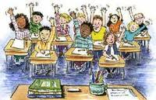
- Students will learn to enjoy and be excited for learning
- Students will learn to love and enjoy reading
- Students will grow academically throughout the year
- Students will be guided in their learning through a positive environment
- Students will believe in their teacher and learn through my actions
Throughout my childhood and schooling to become a teacher I have learned that learning never ends. I believe in guiding students in learning by consistently having a positive attitude and modeling behavior that we want our students to display. I love learning and teaching children life lessons and material they will use in their future.
I look forward to meeting all parents and welcome you to contact or visit my classroom anytime. My phone number is 608-214-7144. My email is tollaksont@uwplatt.edu which I check every day. Communication between parent and teacher is essential in order to give all students the proper instruction and learning experience that every child deserves. I am confident we will all work together and have an extraordinary year.

Sincerely,
Mr. Tollakson

