Name: Thomas Tollakson
Lesson Title: Lets Help
Grade Level: First Grade
Date: 12/2/2013
Information about Students
Total: 13
Males: 8
Females: 5
IEPs: 2
Information about the Lesson
Standard Alignment:
- SL.1.1.c Ask questions to clear up any confusion about the topics and texts under discussion.
Objectives:
- Ask questions to clear up any confusion about the topics and texts under discussion. SL.1.1c
- Build background knowledge about helping others in the community.
- Discuss the Essential Question – how do people help out in the community?
Academic Language:
- Communities
- Principal
- Segregation
- Racism
Lesson Implementation
Purpose Statement: The purpose of this lesson is to introduce students to the idea of helping out in the community, home, school, etc. I want my students to understand that helping others whenever you can is the right thing to do.
Procedures:
- Teacher will build background knowledge on the idea of helping others in the community, home, school, etc.
- Teacher will lead students on a discussion about the Essential Question: How do people help out in the community?
- Teacher will introduce the first two vocabulary words. (leadership & admire)
  - Teacher will use smart board to say the word and use it in a sentence.
  - Students will then “turn and talk” about each word.
  - Students will turn back towards teacher and teacher will call on student volunteers to share their ideas.
- Teacher will read the big book “The Story of Martin Luther King Jr.”
  - Teacher will introduce the students to racism and segregation.
  - Teacher will emphasize how Martin Luther King Jr. helped out not only in his community but worldwide.
- Teacher will display lightening words on smart board.
  - Students will read lightening words from left to write.
  - Since it is our first time reading them we will focus on sounding each word out.
- Teacher will instruct students that on “3” we need to go to our cubbies and get our small book and walk quietly to our seats. When we reach our seats we need to turn to page 74 & 75.
- Teacher and students will read “Thump Thump Helps Out” together as a class.
  - Teacher will ask students questions about the characters, setting, and events.
  - Teacher and students will return to the rug to complete sequencing worksheet on smart board.
- Teacher will close with lesson by asking students “How can you help out in the community?”
  - Teacher will ask students to go home and ask their parents ways they help out in their community.
Differentiation: Teacher will pair the two students who have IEPs with more advanced students. Teacher will write the page number on the board so students can see what the numbers 74 and 75 look like. Teacher will allow students to “shake” their body when they are getting fidgety. The whole class will chorally read “Thump Thump Helps Out” which allows below level readers to listen to students next to them when he/she needs help with a word.
Closure: Teacher will ask students “How can you help out in the community?” Teacher will ask students to go home and ask their parents ways they help out in their community.
Materials:
- Smart Board
- sequencing worksheet
- reading/writing workshop book
- vocabulary word cards (in case smart board does not work properly)
Assessment
Before the Lesson: Teacher will take note of which students he thinks will understand the idea of helping out in the community. Teacher will look at past writing workshop exercises to see which students struggle with ordering their writing and which students have a beginning, middle, and end.
During the Lesson: Teacher will observe students who are actively participating in whole group discussion and partner talk. Teacher will build on student ideas to reinforce participation. Teacher will check in with students who do not have a full understanding of helping out in the community.
After the Lesson: Teacher will read sequencing worksheets to assess which students understand the concept and which students need further instruction. We will work on ordering events during writer’s workshop throughout the week.

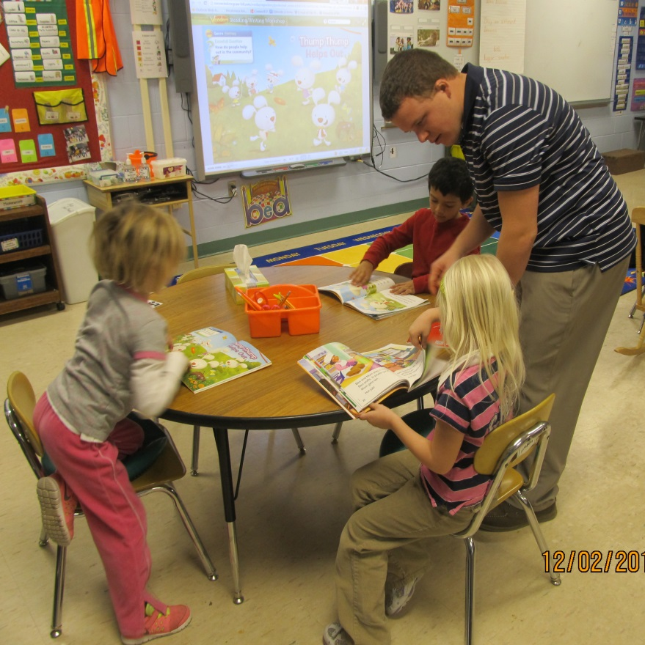
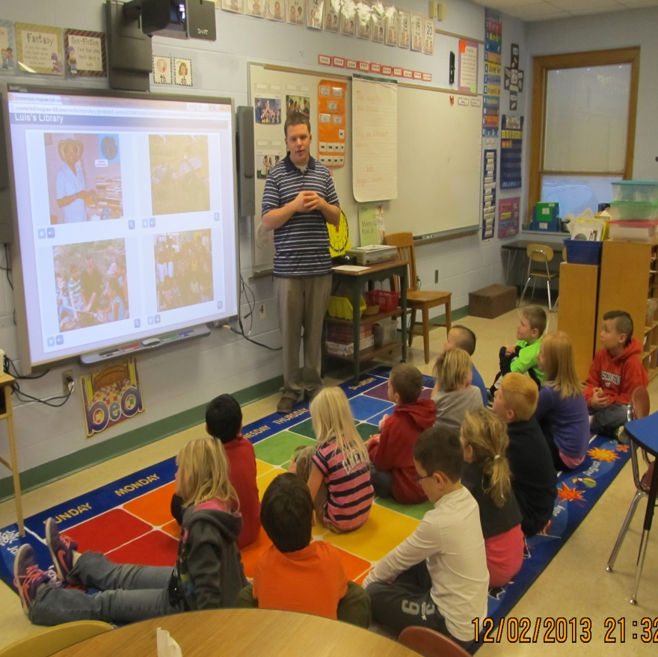
Choral reading of “Thump Thump Helps Out”
We used the Smart Board to listen to an interactive read aloud about how people can help out in the community.

