Classroom Management Plan
Our classroom will be a safe, exciting place to learn, develop, and create in order to open our minds to the world. All students will be positive thinkers and active participants in the learning environment. Students and teacher will work together to help all students strive to reach their full potential.

We will refer to the classroom as “our classroom.” I think it is important that students are the main focus. At the beginning of the year I will ask my students what they would like to learn in our classroom this year. I will pick and choose which topics are appropriate for the grade level. For grades 3-5 we will incorporate student choices into our everyday curriculum. For grades K-2 we will work student choices into our centers. I want my students to have a say in what they learn.

In my classroom we will use BEE Binders (bring everything every day). The BEE Binder goes home every day. Student work, important information, spelling words, homework, and activity and lunch calendars will all be sent home in the BEE Binder. There will be a behavior chart on the back of the BEE Binder. Students will color in the circle with the color that corresponds to the behavior in which they ended the day with. Students will also write a number in the second circle which describes the type of behavior. The behavior chart lets parents know how their child behaved each day. Each folder and pocket is labeled so students know exactly where to put their papers. During the first two weeks of school we will model how to organize our binders. BEE Binders will be a critical part of our classroom because they are a great organizational tool for students and parents.

We will have a prize box with healthy foods, pencils, grips, erasers, books, and bookmarks. I want the prizes to be rewarding and beneficial to students. Students will be rewarded when they bring all their information and papers back the next day. When we have an “aha” moment the whole class will receive a prize from the prize box. When students finish reading a book they will get to choose a prize from the prize box. I want reading to be an essential component in our classroom. I hope to encourage students to be lifelong readers after they leave my class.

Inappropriate behaviors will be addressed by having students move their name down on the behavior chart. A second offense will result in a conference with me about why they are acting inappropriately. A third offense will result in a call to parents in which the student will get on the phone and tell their parents how they are behaving. I want to be proactive in dealing with inappropriate behaviors by talking through the situation with the student. The students and I will make a list of strategies he/she can use to help control and monitor the behavior.

Each student will have a job for the week. Jobs will consist of leader, office, clean up, secretary, mailbox, whiteboard, technician, supplies, math assistant, papers, books, lights, and bus pass. I think it is important that all students have a job. I can always create more jobs if I have more students.

Attention Grabbers

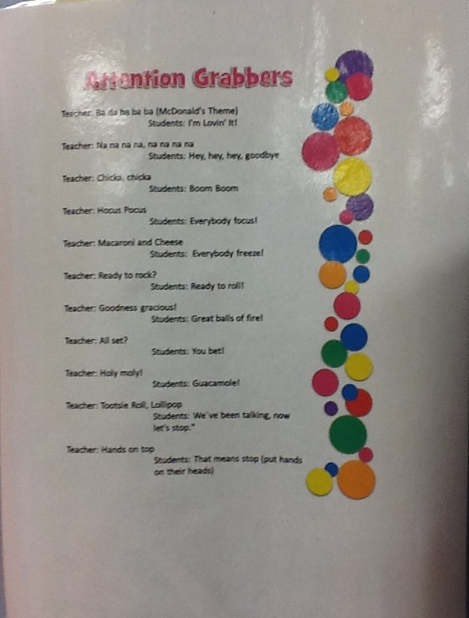
Volume Levels

